QUICK START TO POSTING ON THE MESSAGE BOARD

1. This is the screen that you will be presented with when you LEFT click on the Message Board link from the Message Board and Blog page on www.rosiedwyer.co.uk.
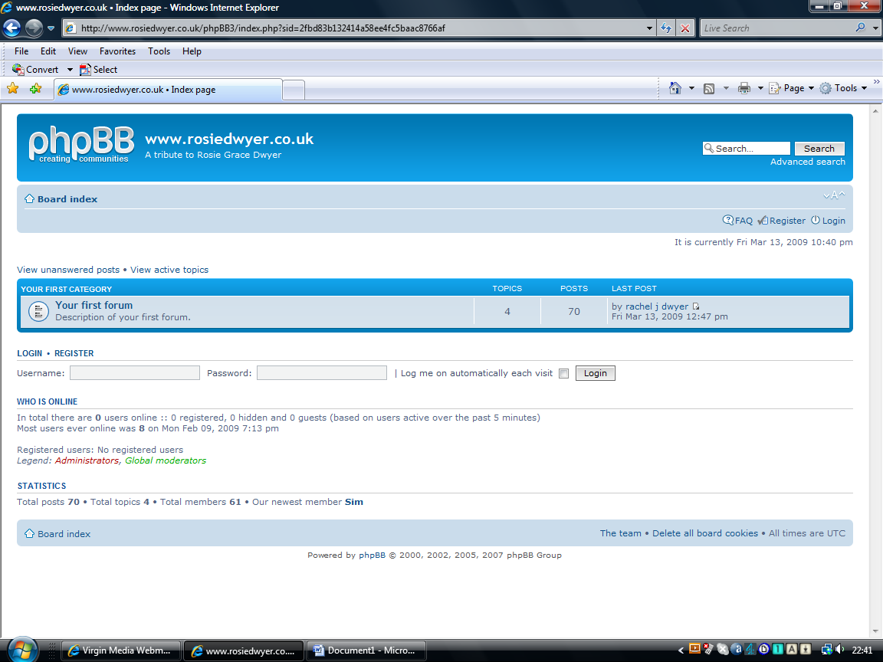
Once registered, use your Username and Password to login.

2. This is the screen you will be presented with after logging in.
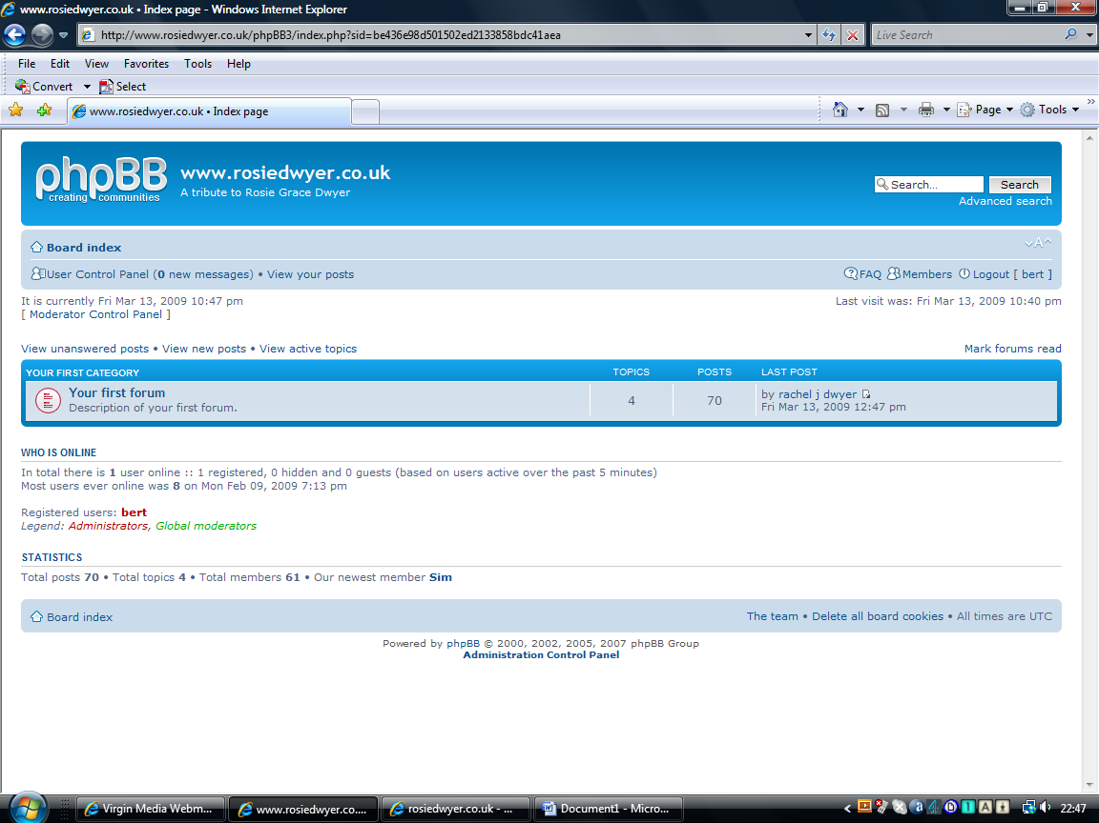
LEFT click on ‘Your first forum’.

3. This will display the list of topics in this forum.
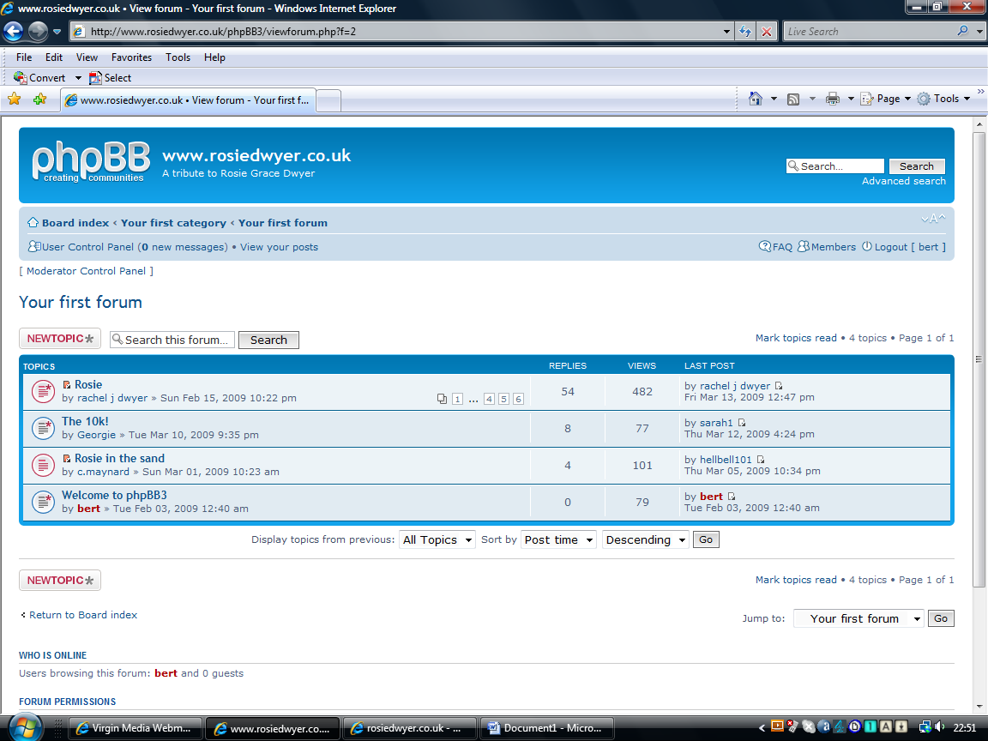
LEFT click on the topic you wish to view. Please note that the list in the above screenshot may change as the board evolves and topics are added to the forum.

4 In this example, I clicked on the ‘Rosie in the sand’ topic and scrolled down to the bottom of the page.

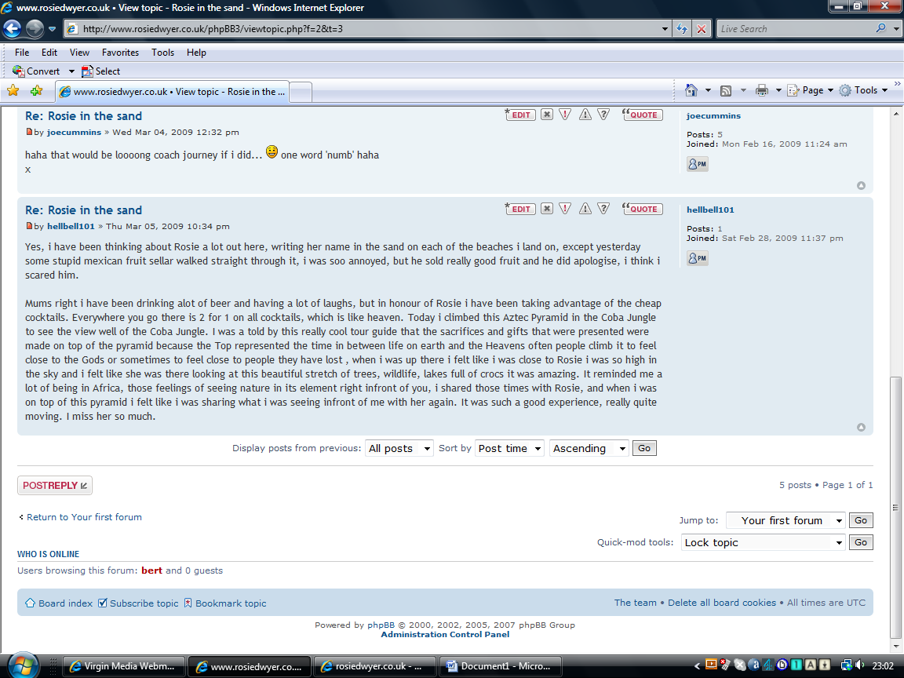

After the last post in the topic, LEFT click on the POSTREPLY button.

5. You will then display a text box for you to type your message:
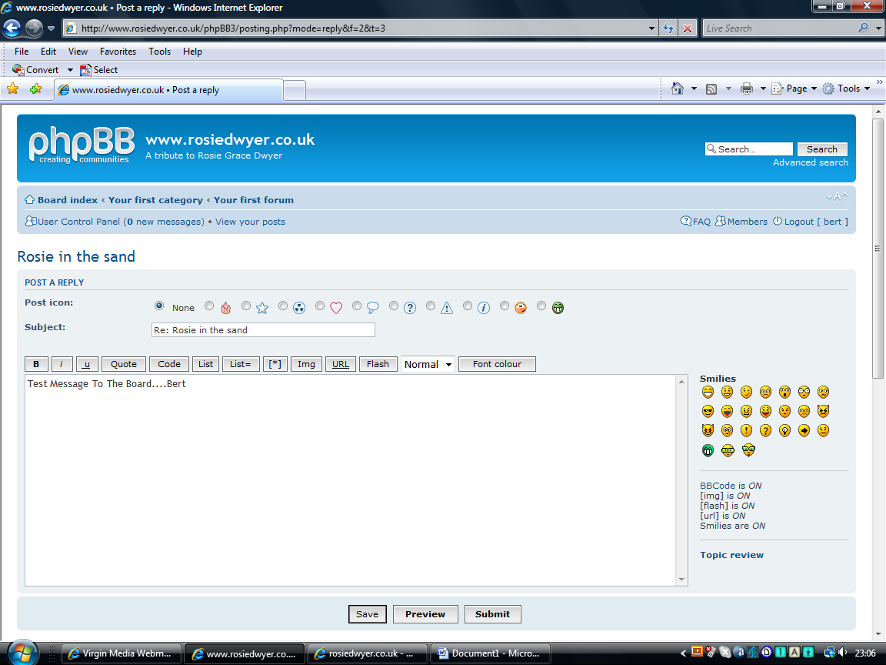
Type your reply. In this example, I’ve entered ‘Test Message To The Board....Bert’. When you are happy with your reply, LEFT click on the 'Submit' button.

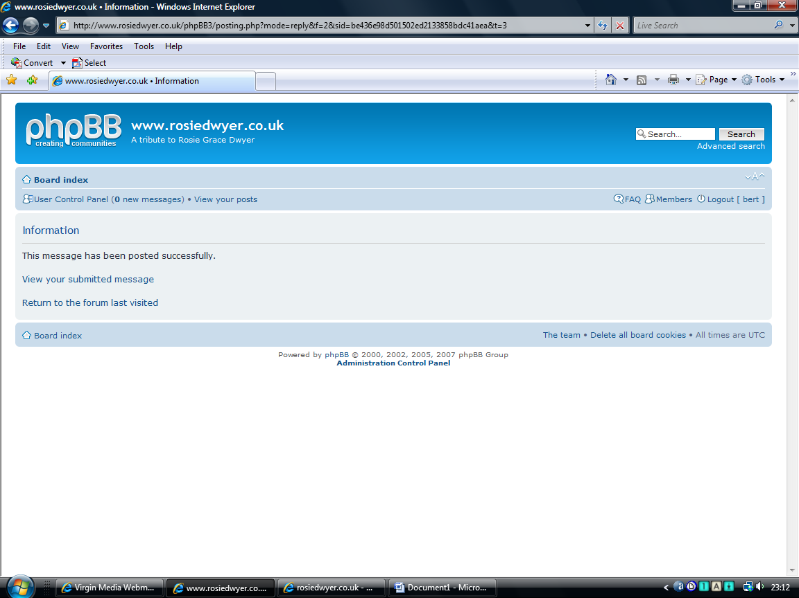

When you see this screen, you have successfully posted your message to the board.

